**EDSON NYONI 201938330189**

**COMPUTER SCIENCE--2019**

**COMPREHENSIVE TRAINING AND SOFTWARE DESIGNING (JAVA)**

**Chapter 1** INTRODUCTION

The main aim of the project is the management of the database of the Students. This project is insight into the design and implementation of a Student Management System. This is done by creating a database of User and Student information. The primary aim of this management system is to improve accuracy and enhance safety and efficiency in the day to day cycle of Student information by admin management.

**Description on the topic:**   
This program can be used in any institution having a database to maintain. The software used can generate result in every window, as per the user’s requirements. The software can insert,update,query and delete Student information. Here, the admin who are handling the organization will be responsible to manage the record of the Students.

**My Objectives**  
**Primary objective**  
•To gain practical experience by modeling a software based on real world problem.   
•To understand how to work on Front-end (Java) and Back-end (MySQL) by using Eclipse IDE.

**Secondary objective**   
•To develop an application that deals with the day to day requirement of Student management.  
•To handle the inventory details like student name, student number, Age,Phone number , Address.

# **Chapter 2 - DESIGN AND IMPLEMENTATON**

Database Design- this is a collection of processes that facilitate the designing, development, implementation and maintenance of enterprise data management systems.

* In this project I designed my database as follows:

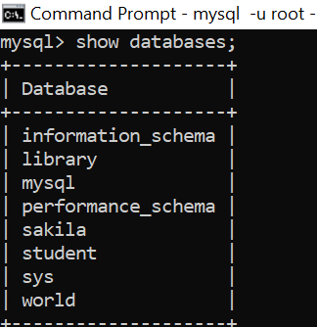

After I created my database I went on to create 2 tables ( user and student )

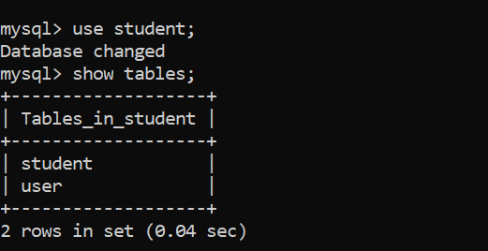

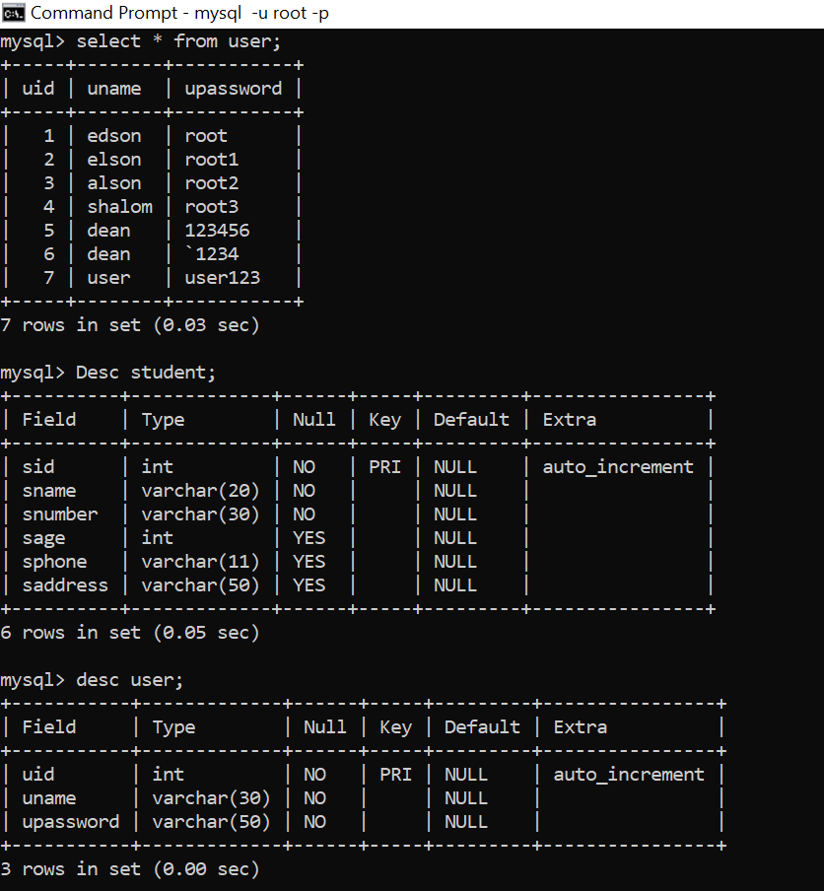

Below is Table_student with student name , student number, Age , Phone number , Address.

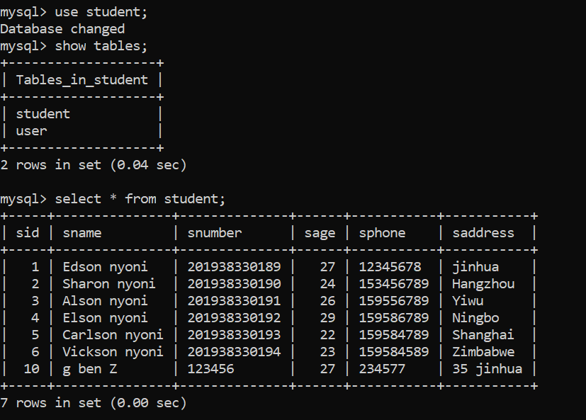

The following is User name and passwords in my Database Student User table

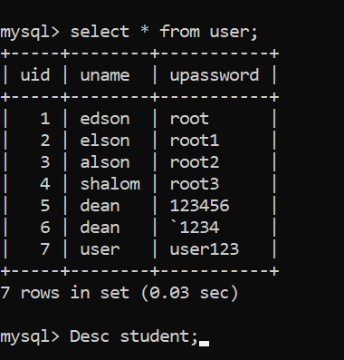

**Sequence Diagram**

Sequence diagram are also called INTERACTION DIAGRAMS. An interaction diagram shows an interaction, consisting of set of objects and their relationship including the messages that may be dispatched among them. It is an introduction that empathizes the time ordering of messages. Graphically a sequence diagram is a table that shows objects arranged along the X-axis and messages ordered in increasing time along the Y-axis



**Activity Diagram**



**CLASS DIAGRAM:**

Class is nothing but a structure that contains both variables and methods. The The following Class Diagram shows a set of classes, interfaces, and collaborations and their relating ships. There is most common diagram in modeling the object oriented systems and are used to give the static view of a system. It shows the dependency between the classes that can be used in our system.

The interactions between the modules or classes of our projects are shown below. Each block contains Class Name, Variables and Methods.



**E-R Diagram**



# Chapter 3 - IMPLEMENTATION

**Description on Implementation**  
The goal of this application is to manage students and various function of the institution.   
  
**List of modules:**

* Login page (Admin , Student and Register new user)

The Registered User Can be Allowed to view inner details for which he Permitted

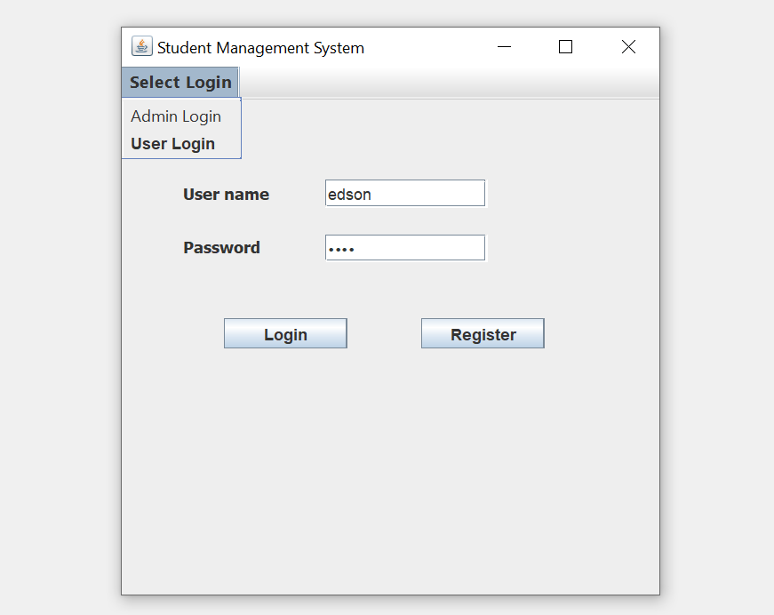

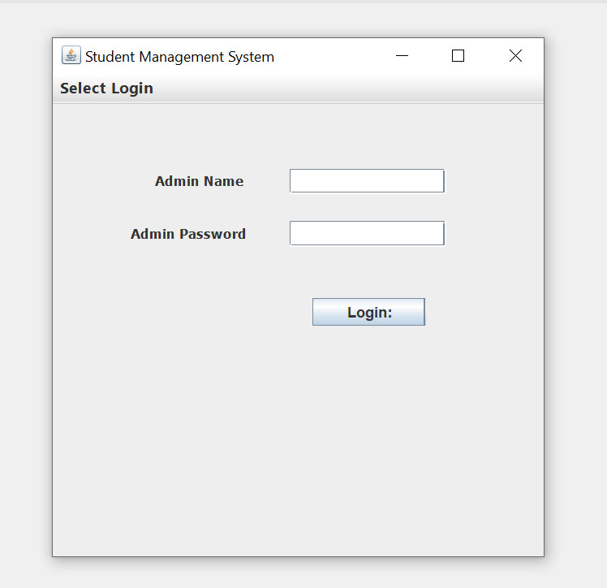

**REGISTER** ----To be authenticated first you have to be registered in the database so that you can be able to login as see below.

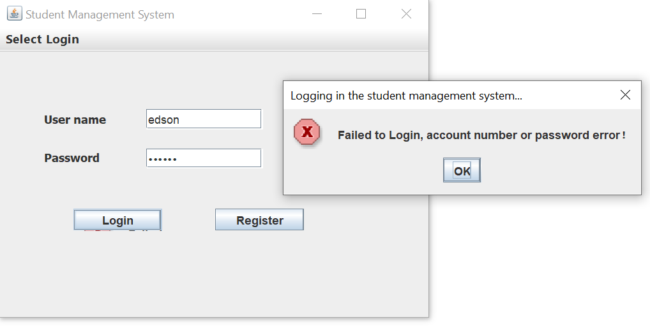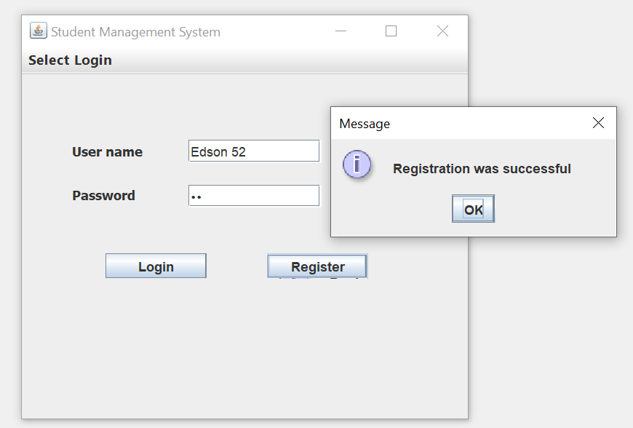

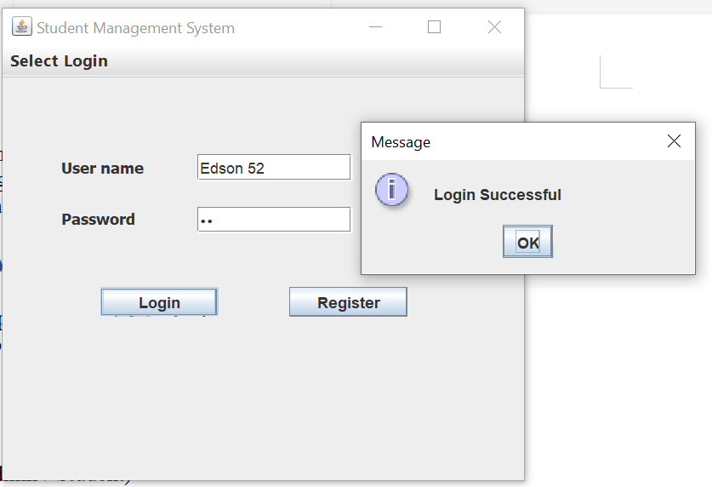

* Student management system table

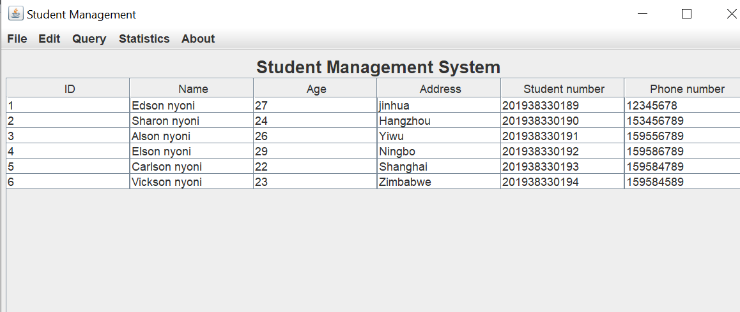

* Edit (insert,update,refresh and delete)

According to my application Admin/User can add, update, query or delete student information in the database.

**Insert Page**

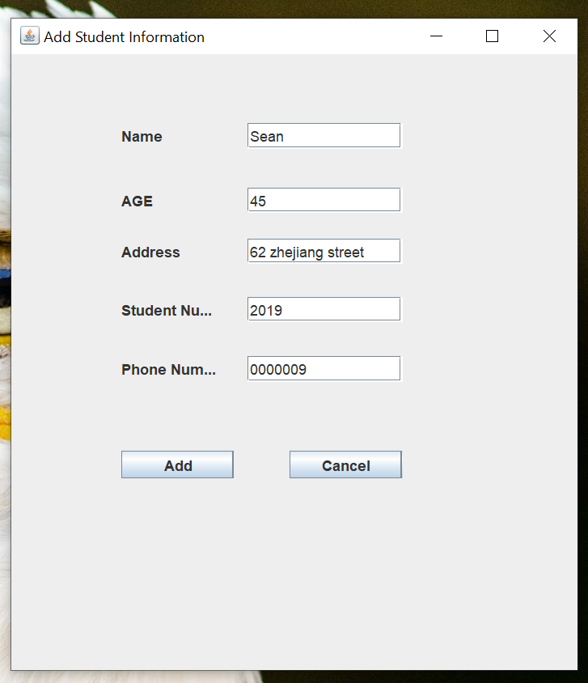

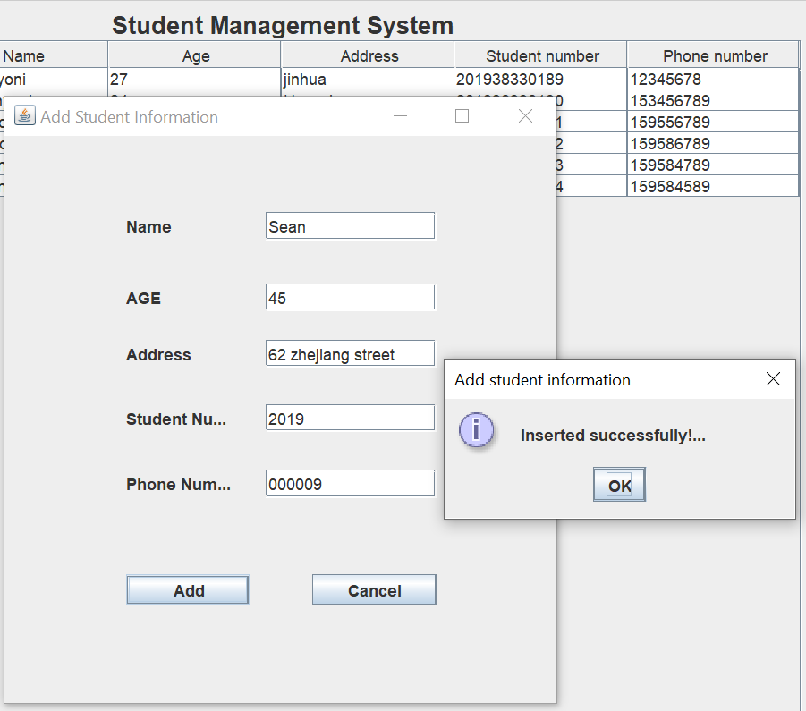

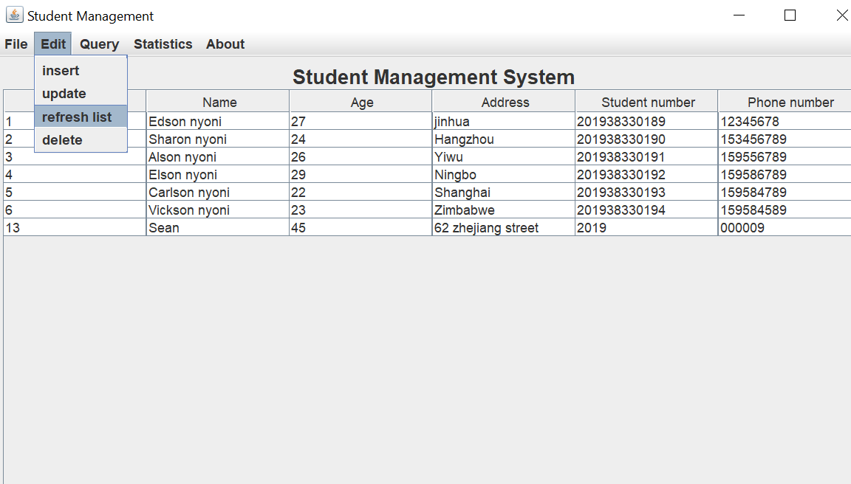

**Update Page**

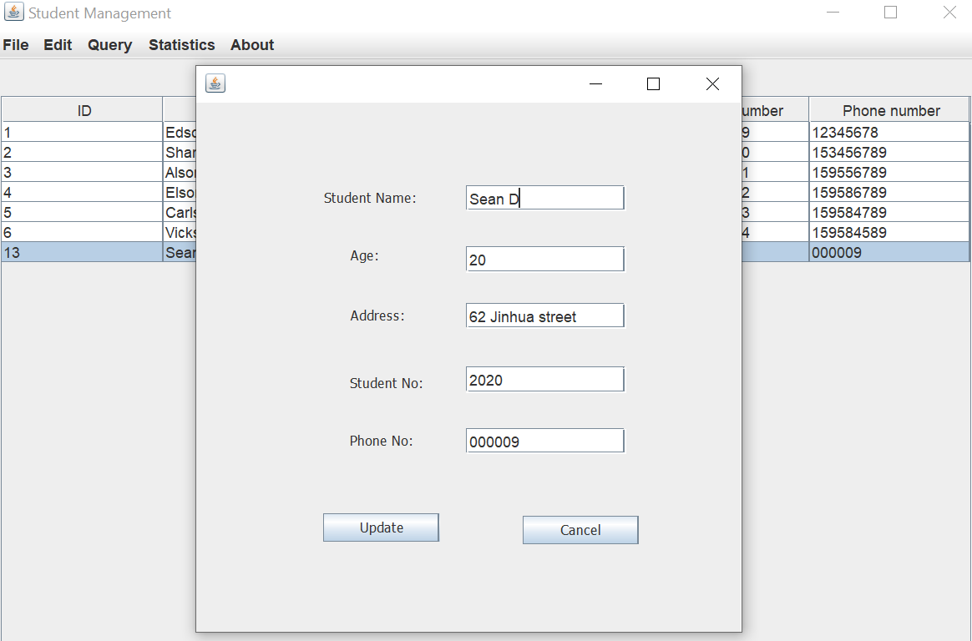

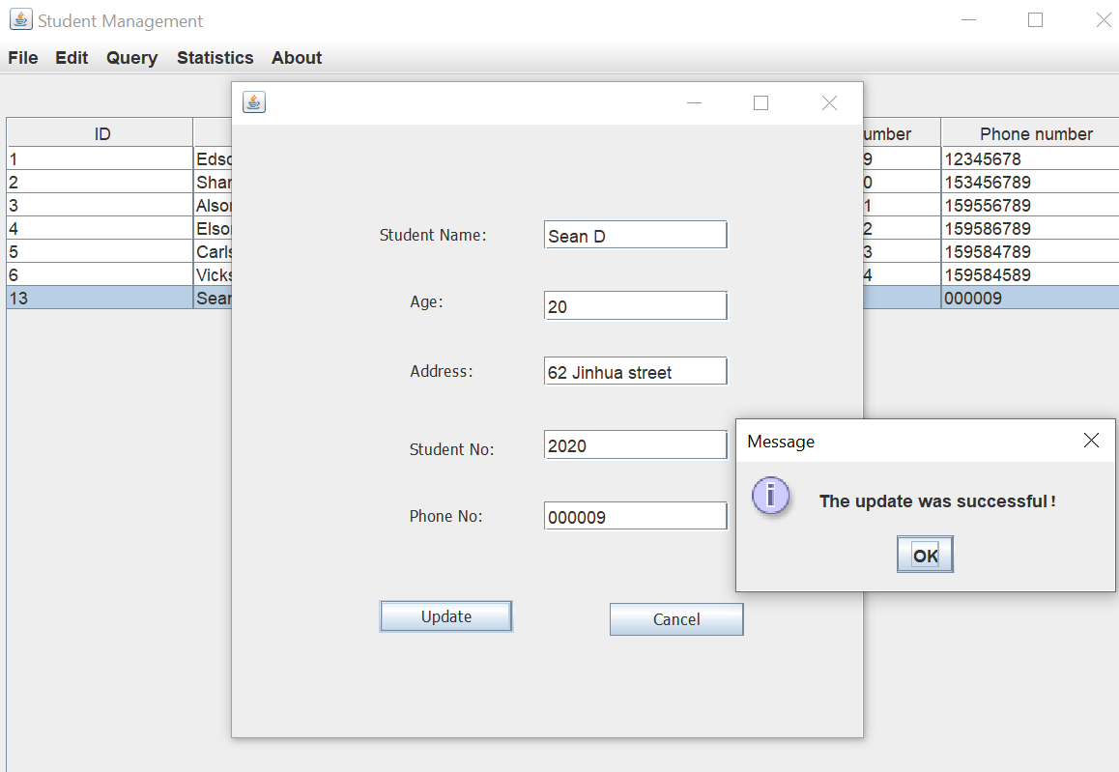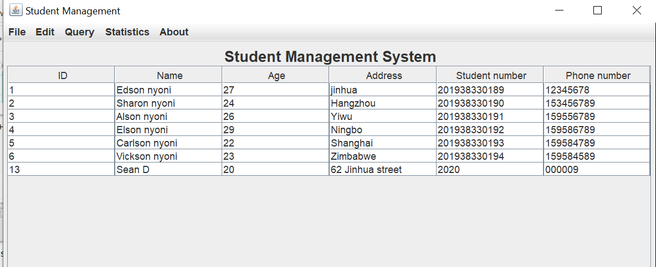

**Delete Page**

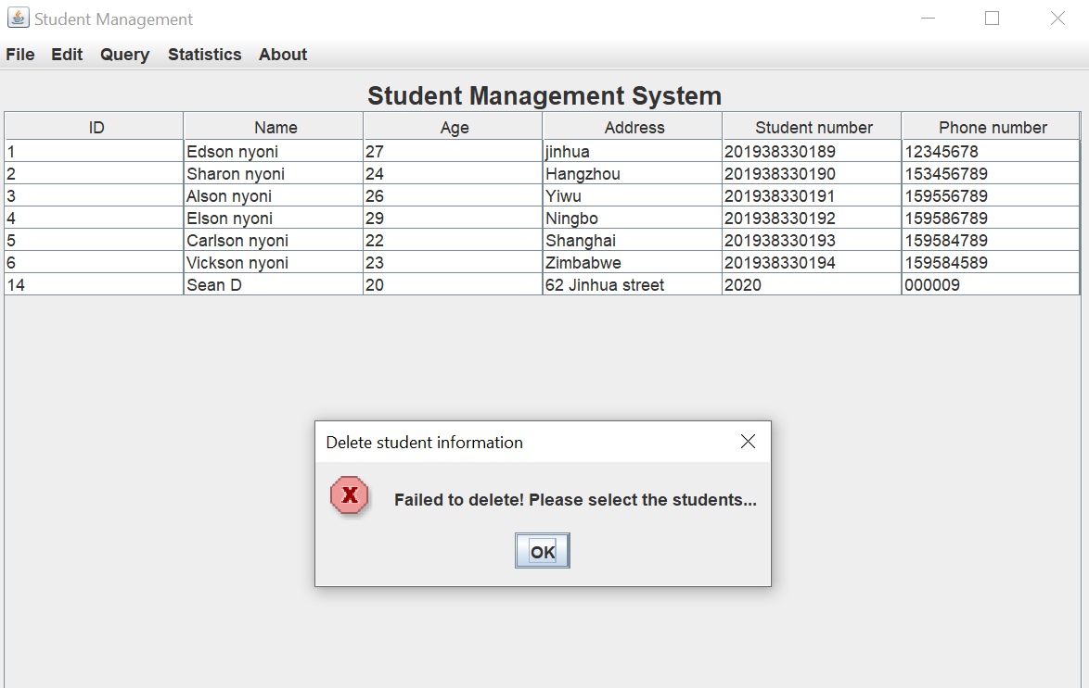

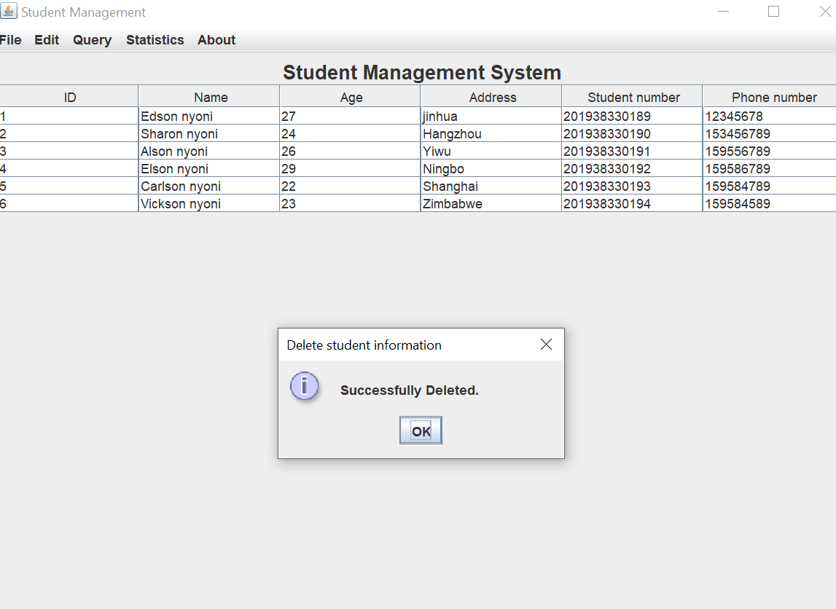

* Query ( by id )

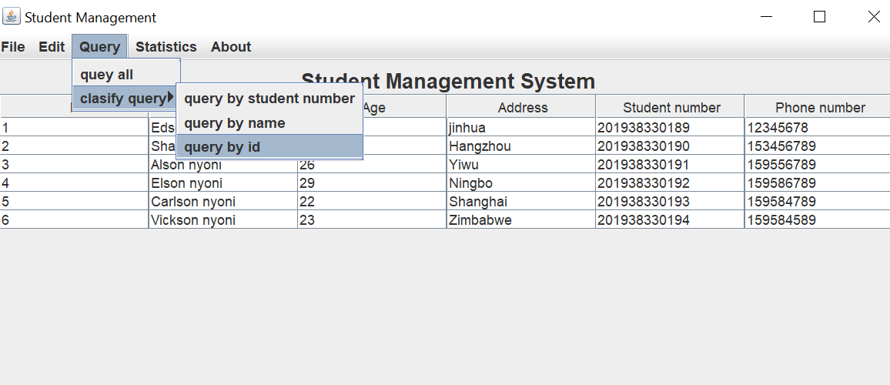

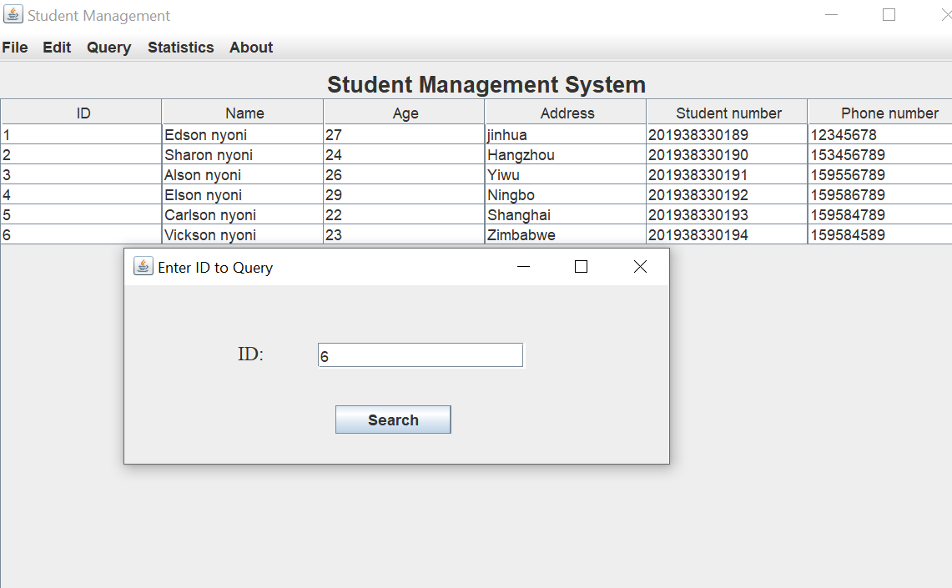

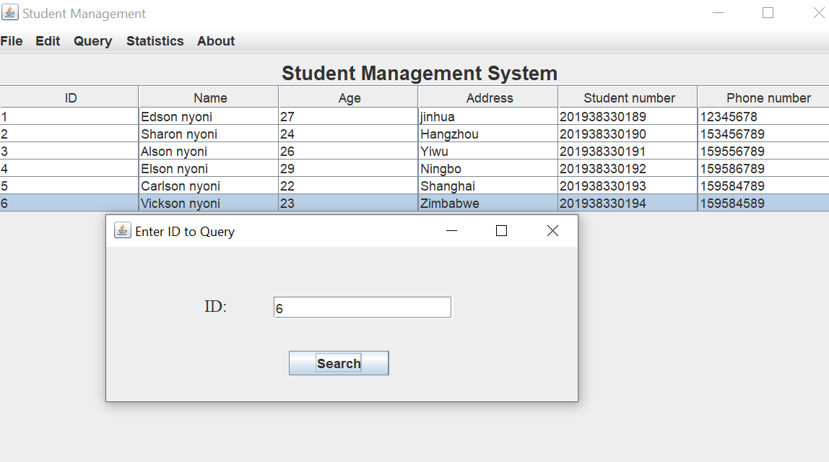

* About

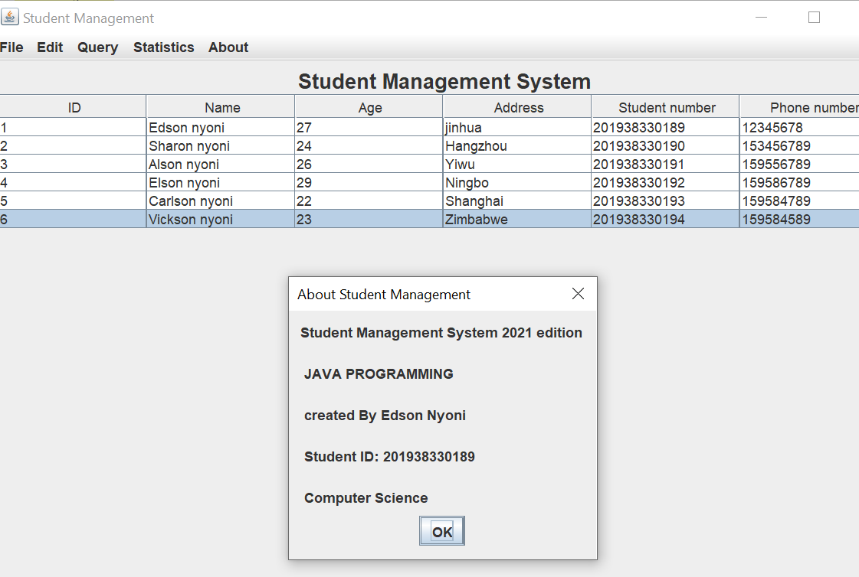

* Quit window

After the all the processes Admin/User can shut down the application using the Quit window.

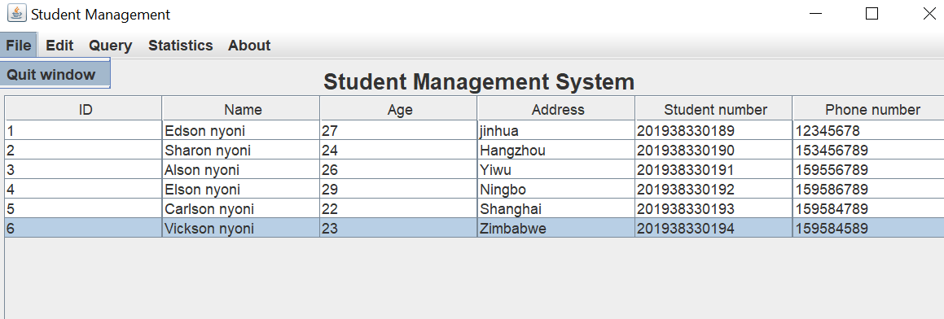

# Chapter 4 - Result and Discussion

By using MySQL commands and its database this application student management system tends to store all the data received from the users in data base. This application provides user with options to insert , update , query and delete students in the system and update the database accordingly. By using Command prompt, database commands are easily initiated into the database and the ER diagrams and flow charts helps us to make the structure of the database and the whole structure of the application faster and it was easier to make them by understanding the needs of the program.

**Login Information**



# **CONCLUSIONS AND FUTURE SCOPE**

The package was designed in such a way that future modifications can be done easily. The following conclusions can be deduced from the development of the project.

* Gathering of detailed information has to be done. Without that , the purpose for using the software won’t be satisfied properly.
* Automation of the entire system improves the efficiency
* It provides a friendly graphical user interface which proves to be better when compared to the existing system.
* It gives appropriate access to the authorized users depending on their permissions.
* It effectively overcomes the delay in communications.
* Updating of information becomes so easier.
* System security, data security and reliability are the striking features.
* The System has adequate scope for modification in future if it is necessary.
* The project can be made more robust by including print button , save as button.
* There is also a scope to expand by implementing newer technologies like automatic login and remember me check box.